Proxy Vote for Proposed Calendar March 2, 2017
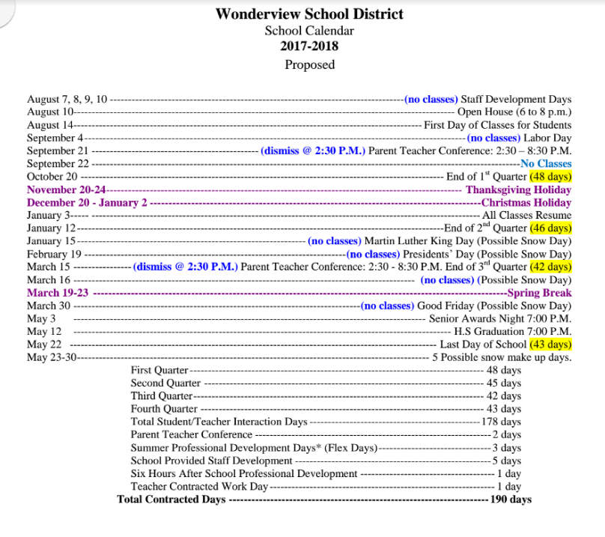

Through voting all were in favor of accepting the proposed calendar for next year and sending it to the school board as is with no changes.

